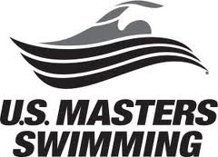
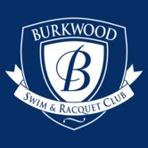

BURKWOOD SWIM & RACQUET CLUB MASTERS/ADULT
SWIMMING

Overview: Whether you are looking for stroke improvement, general fitness, triathlon training, or masters swimming competition we have a lane for you. Separate lanes for different ability levels.

Open to BSRC members AND a limited amount of nonmembers.

Training Days and Times: Starting on 9/2/25
Training is offered year round at the indoor pool at the following times:

Mon-Friday Indoor Pool 5:30-6:30am
Mon/Wed/Fri Indoor Pool 7am-8am
Monday/Wednesday Indoor Pool 7:00-8:00 pm
Saturday- Indoor Pool 8-9:15am

Equipment: May want to purchase a pair of fins but the club has a limited amount to borrow.

Cost: Free to BSRC members.
Nonmembers: $80.00 for 10 practice punch card or $160.00 for 25 class punch
card. May sign up anytime. Fill out the attached application form and bring with you, along with payment, to your first swim practice.

Competition: Participation at US Masters Swimming competitions is offered.

How Do I Sign Up: Fill out the registration form (page two) and either turn into the front desk or bring with you to your first practice along with payment.

Questions??: Contact Burkwood Aquatics at 730-2472 or aquatics@burkwoodclub.com.


TIME TO GET WET!

BURKWOOD SWIM AND RACQUET CLUB
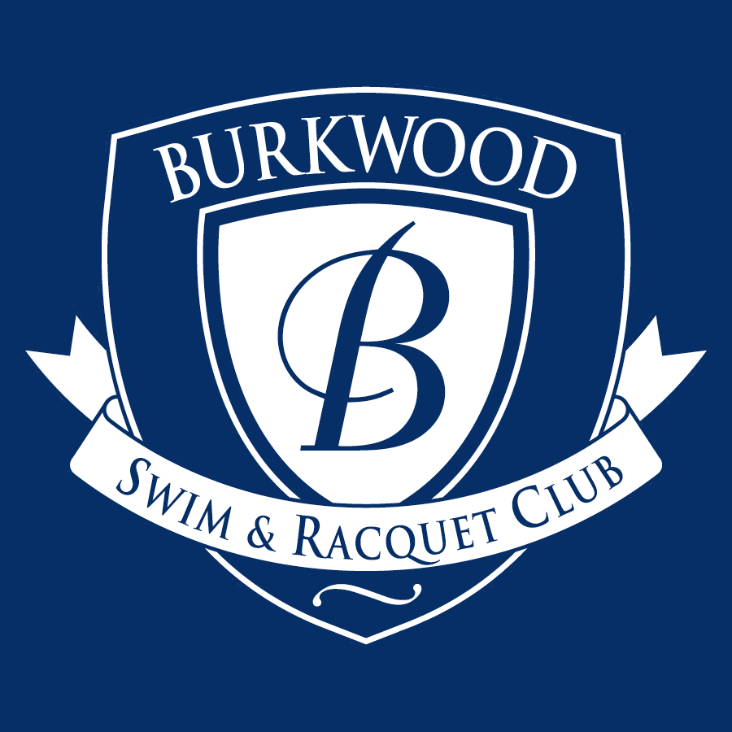
MASTERS SWIMMING SIGN UP FORM

DATE: ______________________________________

NAME: _____________________________________

BSRC Member Number (if applicable): ____________

EMAIL: _____________________________________

Primary Phone: _______________________________

Reason, or reasons for participating in this program?

Any medical conditions that the Master’s coaching staff should be aware of?

TURN IN THIS FORM, ALONG WITH PAYMENT (see page two) TO “BSRC”, TO EITHER THE AQUATICS DIRECTOR OR THE FRONT DESK. You will receive an email confirmation. Your punch card will be available at your first practice however most participants keep their card in the box with the instructor so they do not have to bring it every time.

TIME TO GET WET!

